2025 Annual Report
2026-2031 Transit Development Plan

Prepared by RiverCities Transit Staff
For the Cowlitz Transit Authority
Adopted July 8, 2026

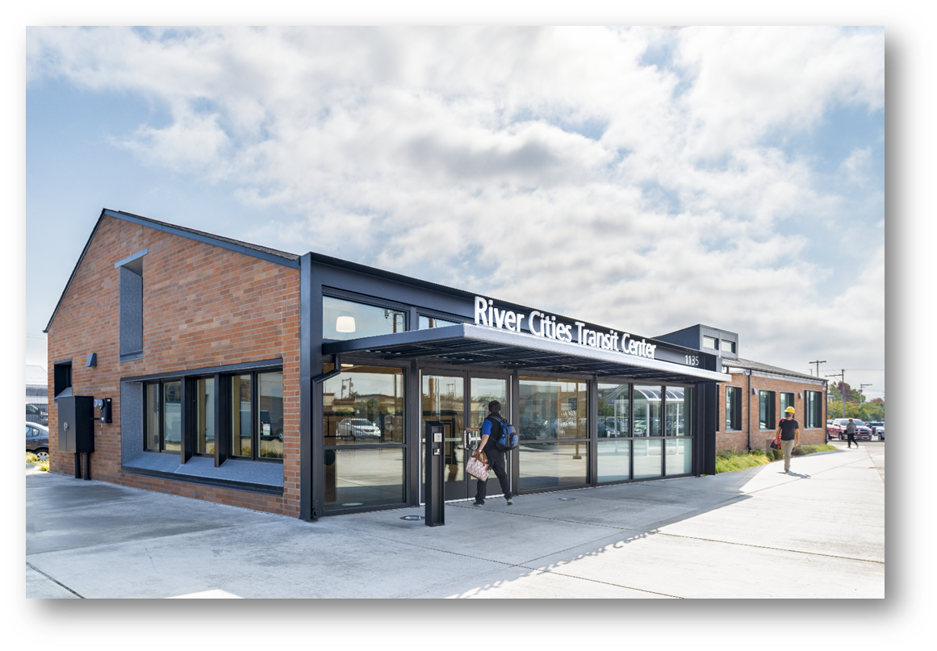

Photo taken by Arthur Ross 09/2020


2025 Annual Report
2026-2031 Transit Development Plan
Prepared by RiverCities Staff
For the Cowlitz Transit Authority
Public Hearing held
July 8, 2026

Americans with Disabilities Act (ADA) Information
This material can be made available in an alternate format by emailing RiverCities Transit at customerservice@rctransit.org or calling (360) 442-5663. Persons who are deaf or hard of hearing may make a request by calling the TTY Relay at 711.

Title VI Notice to Public
It is RiverCities Transit’s policy to assure that no person shall, on the grounds of race, color, national origin or sex, as provided by Title VI of the Civil Rights Act of 1964, be excluded from participation in, be denied the benefits of, or be otherwise discriminated against under any of its federally funded programs and activities. Any person who believes his/her Title VI protection has been violated, may file a complaint with RiverCities Transit or the Federal Transit Administration. For more information regarding our non-discrimination obligations, contact RiverCities Title VI Coordinator at (360) 442-5663.

Table of Contents

Americans with Disabilities Act (ADA) Information 1
Title VI Notice to Public 1
Table of Contents 2
Introduction 4
Plan Adoption, Public Hearing, and Distribution 4
Plan Adoption 4
Public Participation Process 4
Public Hearing 4
Notice of published in the local paper 5
Notice of posted to the website 5
Digital and paper copies of the plan 5
Plan Distribution 5
The Agency 6
History and Governance 6
2024 Cowlitz Transit Authority Board Members 6
2024 Organizational Structure 7
Map 8
Service Area 8
Facilities 9
Longview City Shop 9
Longview Transit Center 10
Kelso Train Depot 11
Heron Pointe Turnaround 11
Operations 12
Fixed Route Operations 12
Fixed Route Fares 13
Paratransit Operations 14
Paratransit Fares 14
Service Connections 15
Wahkiakum on the Move 15
Lower Columbia Community Action Program (CAP) 15
Lewis County Transit 15
Cowlitz Tribe Transit 15
Intermodal Connections 16
State and Agency Goals, Objectives, and Strategies 17
Local performance measures and targets 18
Vehicle Load 18
Vehicle Headway 18
On-Time Performance 18
Service Availability 18
Preventive Maintenance 18
State of Good Repair 18
Useful Life Benchmark (ULB) 19
Planned Capital Expenses 20
Planned Operating Changes 21
Multiyear Financial Plan 22
Capital Improvement: 22
Multiyear Capital Purchases 22
Operating Financial Assumptions: 23
Multiyear Operating Financial Plan 24
Projects of Regional Significance 25
2024 Accomplishments 25
Community Outreach and Partnership Accomplishments 25
Ridership 26
Operating and Performance Data 2024-2029 26
Fixed Route 26
Paratransit 26
Appendix A – Notice of Public Hearing 28
Appendix B - Capital Projects and Estimated Expenditures 28

Introduction
RiverCities Transit (RCT) staff drafts the Transit Development Plan (TDP) annually. The Cowlitz Transit Authority (CTA) then approves it. It fulfills RCWs 35.58.2795 and 35.58.2796. These laws require the creation of a Public Transportation System Six-year Transit Plan and an Annual Report, respectively.
The Washington State Department of Transportation is required to develop an annual report that summarizes the status of public transportation systems in the state for the previous calendar year. RCT submits our annual report to assist in the development of the statewide plan. The document also serves as a tool to communicate our accomplishments and goals to the community. It outlines our organizational structure, transportation services, significant achievements, proposed action strategies, and a program for funding those strategies.

Plan Adoption, Public Hearing, and Distribution

Plan Adoption
The Cowlitz Transit Authority Board adopted the 2025 Annual Report and 2026-2031 Transit Development Plan on July 8, 2026.

Public Participation Process

Public Comment Period June 25, 2026 – July 8, 2026

Comments submitted to customerservice@rctransit.org
RiverCities Transit
PO Box 128
Longview WA 98632

Public Hearing
Cowlitz Transit Authority held a public hearing during the regularly scheduled board meeting on the TDP on July 8, 2026, at 4:00 p.m. No comments were received.

Notice of published in the local paper
The Longview Daily News published notice of the hearing on the Transit Development Plan. A notification will also run in the Longview Lowdown, a bi-weekly newsletter prepared and published by the City of Longview.

Notice of posted to the website
RiverCities Transit will post a notice of the public hearing on the 2025 Annual Report and 2026-2031 Transit Development Plan to its website at www.rctransit.org on June 25, 2026.

Digital and paper copies of the plan
RiverCities will post the 2025 Annual Report and 2026-2031 Transit Development Plan to its website on June 25, 2026, at https://rctransit.org/about-us/planning/. Paper copies are available at the Longview Transit Center at 1135 12th Ave, Longview, WA 98632 upon request.

Plan Distribution
Distribution of the Transit Development Plan will include:
- Washington Department of Transportation
- Transportation Improvement Board
- City of Longview
- City of Kelso
- Cowlitz County
- Southwest Washington Regional Transportation Planning Organization
- Cowlitz Wahkiakum Council of Governments Metropolitan Planning Organization
- Washington State Transit Insurance Pool

The Agency

History and Governance
CTA’s Mission
“To enhance the quality of life in our area, the Cowlitz Transit Authority provides safe, reliable, and efficient transit services that link people, jobs, and communities.”
CTA 2009
RiverCities Transit has a long history in Longview and Kelso, WA. It began 102 years ago, serving mill workers as they traveled to and from work. Several private owners ran the bus service until 1975 when the City of Longview purchased the operation. The City of Longview subsequently became the grant recipient for the Federal Transit Administration and Washington State Department of Transportation.
The Cowlitz Public Transportation Benefit Authority (PTBA) was formed in 1987 to fund the transit system. The Cowlitz Transit Authority (CTA), a five-member board consisting of two members of the Longview City Council, two members of the Kelso City Council, one Cowlitz County Commissioner, and one non-voting Amalgamated Transit Union representative, governs the PTBA. The CTA functions as a taxing authority only. The CTA has contracts for legal counsel and utilizes the services of the Cowlitz County Treasurer but has no other staff. The CTA contracts all transit operations, maintenance, and capital improvement-related functions including management, administration, drivers, and maintenance, to the City of Longview. The City of Longview subcontracts to provide the required complementary paratransit service. The City of Longview and the CTA jointly govern the public transportation system, which operates as RiverCities Transit (RCT). (Figure 1 Organizational Hierarchy Chart)

2025 Cowlitz Transit Authority Board Members
Lisa Alexander Board Chair Kelso City Council Member
MaryAlice Wallis Vice-Chair Longview City Council Member
Stephen Farrell Cowlitz County Commissioner
Erik Halvorson Longview City Council Member
Keenan Harvey Kelso City Council Member
Anthony Harris Non-Voting Amalgamated Transit Union Labor Representative
Mike Karnofski Alternate Kelso City Council Member
Richard Dahl Alternate Cowlitz County Commissioner
Spencer Boudreau Alternate Longview City Council Member

2025 Organizational Structure

Figure 1 Organizational Hierarchy Chart

Map

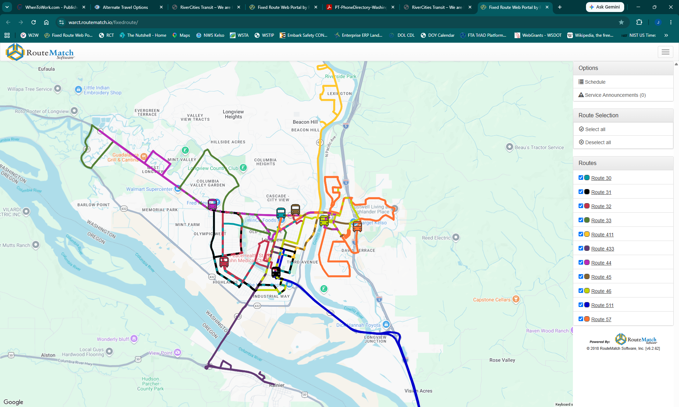
Figure 2 Service Area Map July 2025

Service Area
RiverCities Transit operates within Longview, Kelso, and Lexington-Beacon Hill, Washington, as shown in the above map. (Figure 2 Service Area Map) This service area encompasses approximately 31 square miles as and contains a population of roughly 62,900 residents. Additional commuter bus routes operate from the Longview Transit Center and serve Rainier, Oregon and the I-5 Corridor with stops in Kalama, Woodland industrial area, central Woodland, Cowlitz Indian Tribe Reservation (ilani), and Vancouver.

Facilities

Longview City Shop
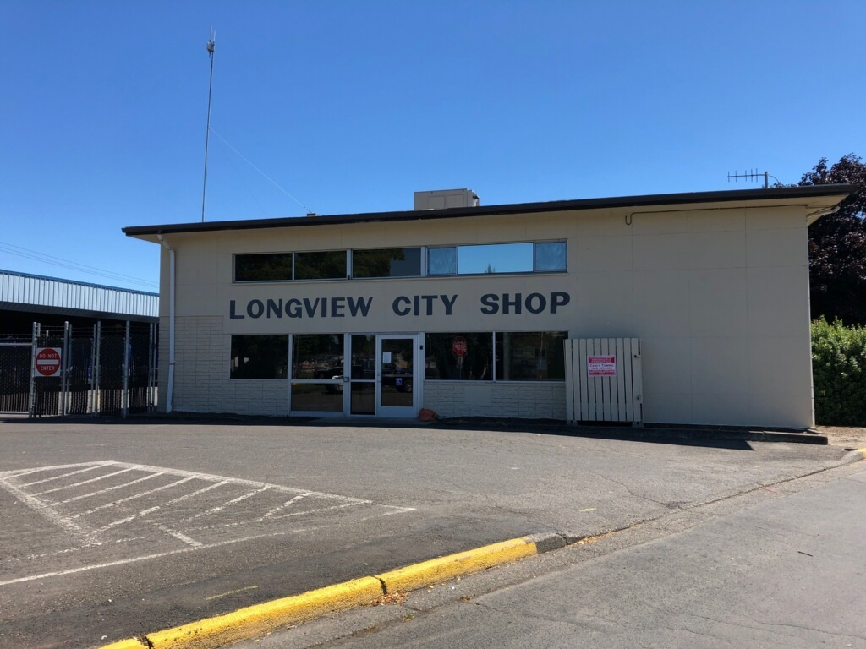RiverCities Transit and RiverCities LIFT dispatch from the Longview City Shop (Figure 3 Longview City Shop) at 254 Oregon Way, Longview WA. The facility is approximately 8,000 SF; in addition to Transit, it houses the Fleet Maintenance, Facilities Maintenance, and the entire City of Longview fleet. The Shop building roof and HVAC system were both replaced in 2024.

Longview Transit Center
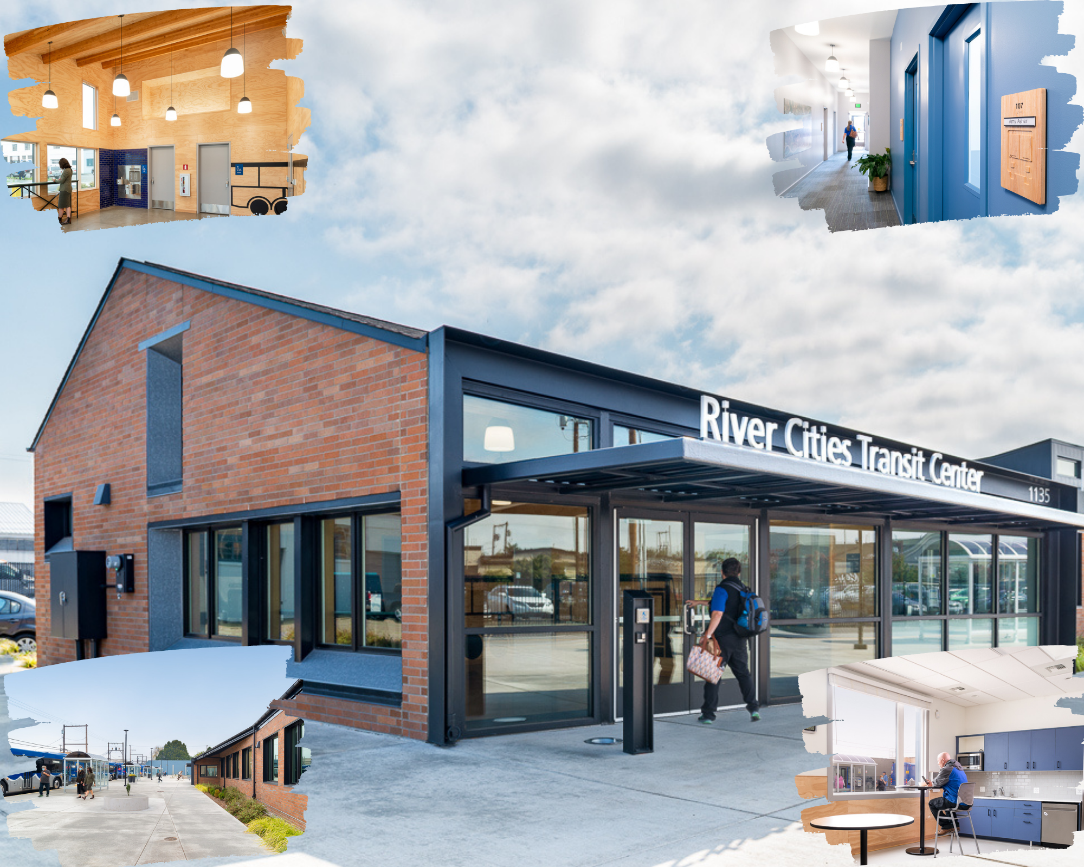
The Transit Center (Figure 4 Transit Center), located in downtown Longview at 1135 12th Avenue, opened January 30, 2020. This facility includes a lobby with a customer service window, administrative offices, training room, and break rooms for operators and administrative staff. Seven RCT fixed routes and two regional service providers serve the Longview Transit Center.
Photos taken by Arthur Ross 09/2020
Figure 4 Longview Transit Center

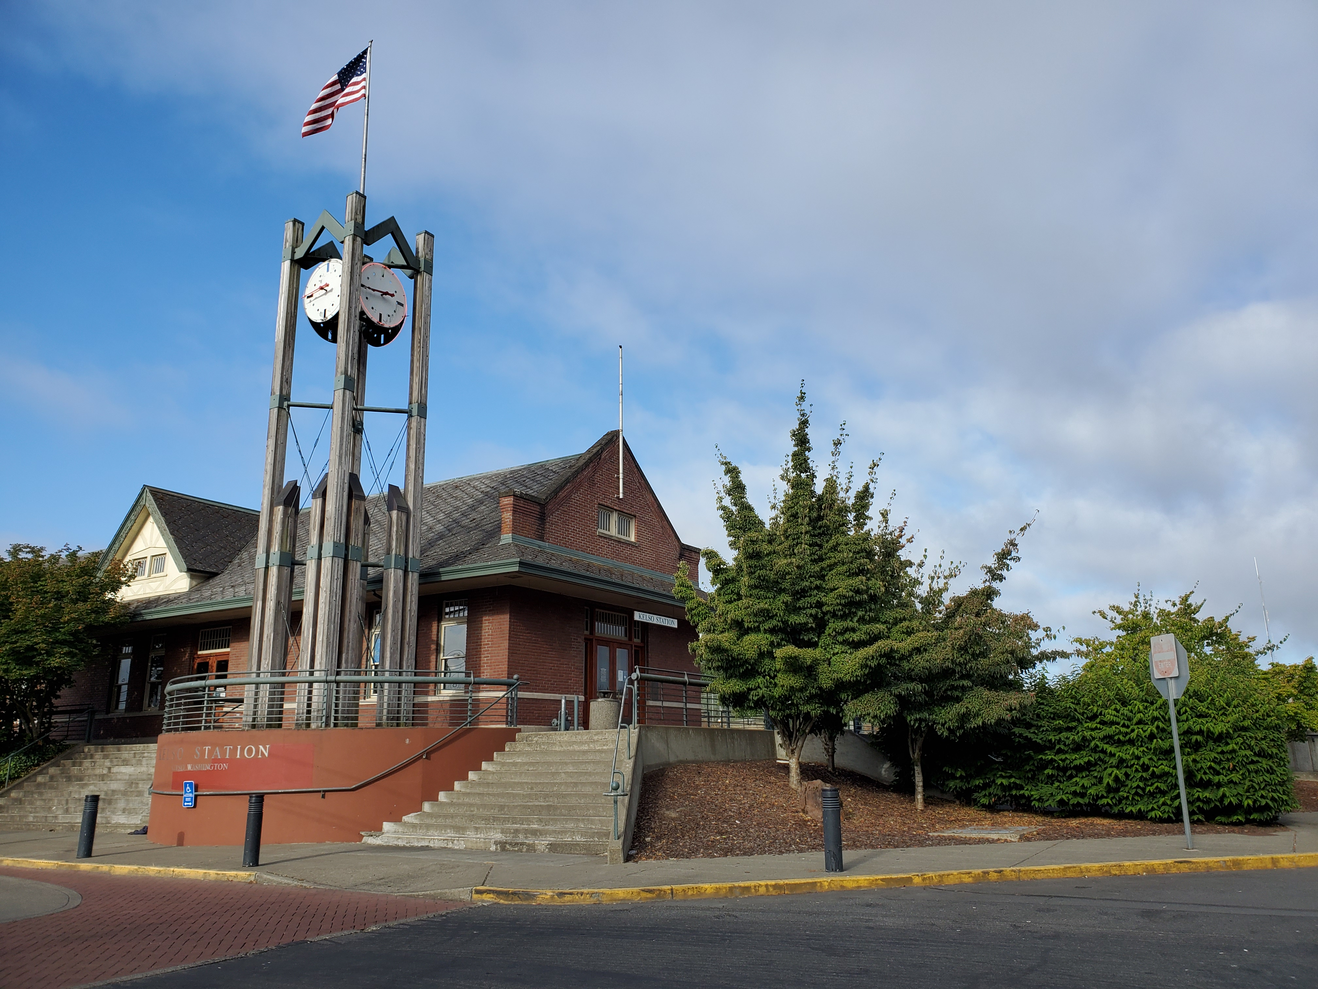Kelso Train Depot
Located at 501 S First Street, Kelso, WA, the Kelso Train Depot (Figure 5 Kelso Train Depot) is a multimodal location with connections to Amtrak, Greyhound (Flixbus), Wahkiakum on the Move, and four RiverCities Transit fixed routes. RiverCities Transit rents a breakroom for operators from the City of Kelso at the Kelso Train Depot.

Heron Pointe Turnaround
Built in 2012, the Heron Pointe turnaround (Figure 6 Heron Pointe) is used by RCT to turn westbound Route 44 eastbound safely. Route 33 also serves Heron Pointe.
Photo by Michael Richards 08/2020
Figure 5 Kelso Train Depot
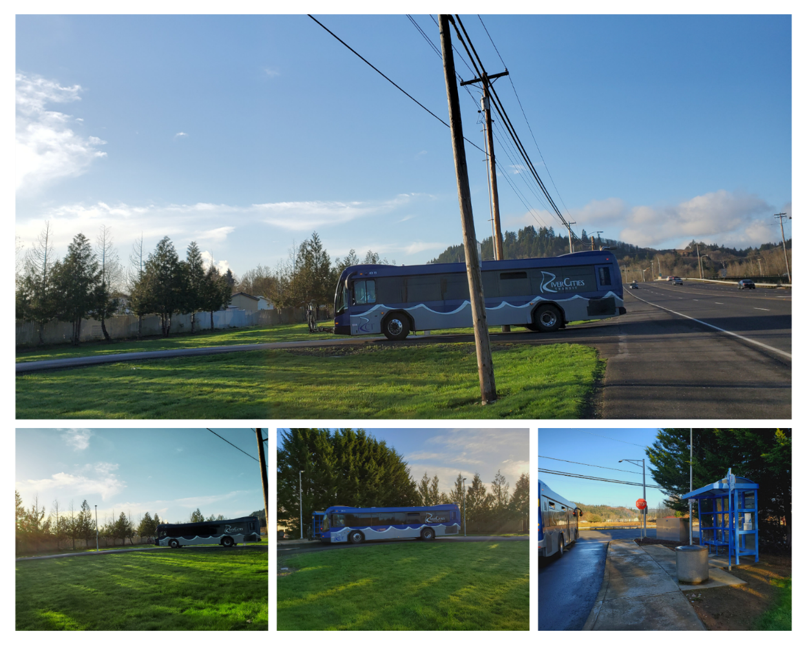
Figure 6 Heron Pointe
Turnaround
Photos taken by Tabitha Hayden 08/2020

Operations
RiverCities Transit services include Fixed Route. Commuter Bus, and Paratransit.

Fixed Route Operations
RiverCities Transit operates eleven fixed routes, two commuter routes and nine local routes within the urban areas of Longview, Kelso, and Lexington, WA. RCT’s fixed routes circulate through most urbanized neighborhoods in Longview and Kelso from 6:30 AM to 7 PM, Monday through Friday. Six routes operate Saturday from 8 AM to 6 PM.
RCT designed seven routes to complete a round trip in fifty minutes, allowing them to run on sixty-minute headways. This scheduling enables transfer connections at the Transit Center, Kelso Train Depot, and the Three Rivers Mall. This scheduling provides simplicity and convenience for customers, allowing passengers to travel between almost two points in the Longview-Kelso region with a maximum of one transfer and little wait time for transfers.
RCT’s most heavily traveled route offers service every thirty minutes during the morning and evening runs. Midday, Route 45 runs on a forty-minute schedule with a second bus, offering service every twenty minutes.
The Lexington Connector, Route 411, was launched in May 2022 and provides service between Longview and Lexington/Beacon Hill, a suburb of Kelso. Despite the defeat of a ballot measure to annex those neighborhoods, the CTA Board continues Route 411 with WSDOT and CTA funding.

Commuter Bus Operations
Two new commuter bus routes were implemented July 1, 2025. The vehicles are ADA accessible, However, as these are limited commuter routes, there is no complementary ADA paratransit service required.
Route 433 to Rainier, OR, operates five times per weekday, serving the Rainier Transit Center and Rainier Senior Center with direct service to the Longview Transit Center.
Route 511 to Vancouver also operates five times per weekday. Route 511 replaces a service previously provided by Lower Columbia Community Action Program after that agency announced its intent to discontinue service. RCT added two additional stops and the service new connects the Longview Transit Center, Kalama, the North Woodland industrial area, central Woodland, the Cowlitz Tribe Reservation at ilani, and 99th Street Transit Center in Vancouver. This service provides the only connecting bus service between Longview and Vancouver, as Greyhound and Flix no longer stop between Olympia and Portland.

Fixed Route and Commuter Bus Fares
Fares and pass prices established on January 1, 2016, and revised in 2022, are shown in Figure 7. Passes entitle the holder to unlimited rides during their specified periods and are nontransferable. Transfers are free with the purchase of one-way fare and valid for one use only on the day of purchase.
 | One – Way Fare | Daily Pass | Monthly Pass | Quarterly Pass | Annual Pass
Adult | $1.00 | $2.00 | $14.00 | $42.00 | $168.00
Student | $1.00 | $2.00 | $7.00 | $21.00 | $84.00
Reduced | $.50 | $1.00 | $7.00 | $21.00 | $84.00
LCC Students & Faculty | Free
LIFT Approved | Free
PCA | Free
Youth Pass |  |  |  |  | Free
Figure 7 Fixed Route and Commuter Bus Fare Table

Adult passes are for those ages 18 and older.

- Student passes are available to those with a student ID showing the holder is currently attending classes and earning college credit at an accredited school of higher education.
  - Student Summer Passes are issued at twice the rate of a monthly student pass and are valid June 1st through August 31st each year.
- Reduced fare is available to citizens aged 65 or older, Medicare cardholders, and persons with disabilities. Applicants are required to show proof of age, Medicare Card, or complete an application for a reduced fare permit.
- LCC (Lower Columbia College) pays an annual fee based on its students and staffs prior year’s ridership. Those wishing to take advantage of the program show their LCC ID to the bus operator.
- LIFT qualified individuals are eligible to ride fixed route free of charge.
- PCA (personal care attendant) rides free of charge when accompanying a LIFT qualified individual.
- Youth pass is a free annual pass available to those eighteen and younger who turn in a completed consent form or carry other proper age-specific identification. The Annual Youth Pass is a pilot program that started in January 2020 and was extended through December 31, 2025 to encourage local youth to ride transit and to reduce the transportation barrier to youth activities and programs. Youth under the age of twelve (12) must be accompanied by a parent or guardian. The Youth Pass program also is also a state requirement for receiving a Transit Support Grant funded by the Climate Commitment Act.

Paratransit Operations
RCT provides federally mandated complementary paratransit service within ¾ of a mile of all fixed routes according to the Americans with Disabilities Act (ADA) requirements. The service area boundary is shown in Figure 2. This service is identified as RiverCities LIFT. The City of Longview contracts with Paratransit Services Inc. to operate LIFT. Paratransit Services Inc. is a non-profit organization headquartered in Bremerton, Washington. Paratransit Services Inc provides the operators, scheduling/dispatch staff, supervisor, and a manager. The City of Longview owns and provides the vehicles. Effective November 2024, the CTA Board extended the ADA boundary to 1 mile for a two-year pilot project.
To qualify for LIFT, individuals must complete an application process and be certified as unable to independently utilize fixed route transportation due to their disability. LIFT provides paratransit service on a next-day reservation basis. In addition, LIFT offers same-day response as a “premium” service at an additional cost. LIFT operates on the same schedule as fixed route service weekdays from 6:30 AM to 7 PM and Saturday from 8 AM to 6 PM. LIFT provides trips for any purpose and does not limit the number of trips an individual may take. The ADA requires there to be no capacity constraints or trip denials.
RiverCities Transit provides ADA complementary paratransit service to the area 1 mile around Route 411 – Lexington Connector by deviating from the fixed route bus to provide curb-to-curb service.

Paratransit Fares
Fares and prices established on January 1, 2016 shown in Figure 8.
 | One – Way Fare | Monthly Pass | 5 Ride Punch Card | 20 Ride Punch Card
LIFT Approved | $1.00 | $15.00 | $5.00 | $10.00
PCA | Free
Youth Pass | Free | Free
Figure 8 Paratransit Fare Table

Service Connections
In addition to services provided by RCT, several regional programs operate services from outlying areas to the Longview – Kelso area. Longview-Kelso serves as a regional destination for medical appointments, shopping, employment, school, and other transportation connections. These connections are each described below. RCT is a partner with many of these agencies as they utilize the Longview Transit Center.

Wahkiakum on the Move
Wahkiakum on the Move (WOTM) provides service between Cathlamet and Longview-Kelso four times a day and between Naselle (with connections to Pacific Transit in Pacific County) and Longview-Kelso twice a day. WOTM makes connections with RCT at the Kelso Train Depot and the Longview Transit Center. They also stop at St John’s Medical Center, the 7th Avenue Wal-Mart, Triangle Mall, and Fred Meyers. While the service is available to the public, half of the WOTM riders are seniors. Passengers use the service to access shopping, medical appointments, and LCC.

Lower Columbia Community Action Program (CAP)
The Lower Columbia Community Action Program (CAP) provided two transportation services in the Longview-Kelso area in the first half of 2025. CAP offered Senior Transportation to those age 60 and over. This service was for those residents living outside the RiverCities Transit service area to come into Longview-Kelso for medical appointments and for all seniors to get to medical appointments in the Portland-Vancouver area to the south and as far north as Olympia. They provided medical and shopping trips in wheelchair- accessible vans to residents living outside and inside the RCT service area. CAP Transportation offered a fixed route service from the Longview Transit Center to the Vancouver 99th Street Station six times a day. This service was available to the public and cost two dollars each way. The service to Vancouver ceased on June 30, 2025 due to a lack of funding. The Cowlitz Transit Authority authorized RiverCities Transit to begin a modified level of service between Longview and Vancouver effective July 1, 2025.

Lewis County Transit
Lewis County Transit (LCT) provides fixed route service, dial-a-ride service (DARTT), and paratransit service (LIFTT) in Lewis County. LCT’s fixed route bus service operates throughout the twin cities of Centralia and Chehalis, Washington and eastern Lewis County. LCT’s fixed route service includes express service between Centralia and Tumwater/Olympia, where LCT connects with Intercity Transit, Greys Harbor Transit, Mason Transit, and Rural Transit; also, between Centralia and the Castle Rock Visitor Center/Park & Ride onto Kelso, WA where it connects with RiverCities Transit.

Cowlitz Tribe Transit
The Cowlitz Indian Tribe provides public transit service to rural residents in South Lewis and Cowlitz Counties Monday through Friday who live up to 20 miles from the I-5 corridor. The Tribe does not provide service within Longview except when requested by a tribal member. People needing transportation within Longview and Kelso are referred to RCT.
CC Rider (Columbia County, OR)
RiverCities Transit Route 433 connects with the CC Rider service between Portland and Rainier at the Rainier Transit Center.
C-TRAN (Clark County)
C-TRAN provides fixed route service, ADA paratransit (C-VAN), and a shared-ride micro-transit service (The Current) throughout much of Clark County with express service to Portland. RiverCities Transit Route 511 connects with C-TRAN at the Cowlitz Indian Tribe Reservation and at the 99th Street Transit Center.

Intermodal Connections
Several other services provide regional public transportation connections. RCT makes connections with Amtrak at the Kelso Train Depot. It also connects with several rural and paratransit providers, as previously described. Greyhound and FlixBus discontinued intercity motorcoach service to Kelso in 2024.

State and Agency Goals, Objectives, and Strategies
Efforts by RiverCities Transit from 2026-2031 will address the following strategies. The figure below (Figure 9 Goals, Objectives, and Strategies) shows how RCT’s strategies align with the state goals established in the Washington State Transportation Plan and defined below.
 | State Goal Areas
Goals, Objectives and Strategies | Economic Vitality | Preservation | Safety | Mobility | Environment | Stewardship
Operate transportation systems reliably and responsibly. | X | X |  |  |  | X
Provide viable mobility choices for the customer and expand the system to accommodate growth and future transportation infrastructure. | X |  | X | X |  | X
Implement facilities and equipment solutions that are in the best interest of the community. | X | X | X | X | X | X
Figure 9 Goals, Objectives, and Strategies Table

- Economic Vitality: To promote and develop transportation systems that stimulate, support, and enhance the movement of people and goods to ensure a prosperous economy.
- Preservation: To maintain, preserve, and extend the life and utility of prior investments in transportation systems and services.
- Safety: To provide for and improve the safety and security of transportation customers and the transportation system.
- Mobility: To improve the predictable movement of goods and people throughout Washington State.
- Environment: To enhance Washington’s quality of life through transportation investments that promote energy conservation, enhance healthy communities, and protect the environment.
- Stewardship: To continuously improve the quality, effectiveness, and efficiency of the transportation system.

Local performance measures and targets

Vehicle Load
Vehicle load indicates the extent or probability of overcrowding and may indicate the need for additional vehicles to maintain useful service. RCT monitors the vehicle load factor to ensure that it does not exceed 1.5. A vehicle load factor of 1.5 would mean all thirty seats are occupied, with approximately fifteen passengers left standing. Vehicle Load Factor is reviewed regularly using passenger count data to determine whether additional capacity should be added to specific trips or routes based on passenger demand.

Vehicle Headway
RiverCities Transit has a vehicle headway goal of at least 45-minute headways on all routes. RCT currently operates eight routes on 60-minute headways and one route on a variable headway of 20 to 30 minutes. Several factors, including ridership productivity, transit and pedestrian friendly streets, and density of transit dependent population and activities, will determine headway standards for future routes.

On-Time Performance
On-time performance is an indicator of RCT’s service reliability. A bus is considered late if it departs the published time point five or more minutes later than the scheduled time. A bus is considered early if it leaves from a published time point before the scheduled departure. RCT’s goal is to be on time at least 90 percent of the time.

Service Availability
RCT aims to ensure all residents of the urbanized area live within one-half mile of a bus stop provided geographic constraints, such as rivers and topography. Transit access is determined using the Geographic Information Systems (GIS) by mapping the distance of all bus stops to the centroid of 2020 Census block groups.

Preventive Maintenance
RiverCities Transit’s preventive maintenance intervals for fleet vehicles are conducted based on the number of miles driven and are met within +/- 10% of the defined mileage. These preventive maintenance schedules are adhered to at least 80% of the time to meet FTA’s required on-time threshold, with a goal of completing preventative maintenance 100% on time.

State of Good Repair
Decisions to repair, replace, and expand capital assets are conducted based on the ongoing communication between Fleet, Transit, and the Executive Office of the City of Longview. The condition rating, defined in the table below (Figure 10 Transit Asset Condition Rating Scale), serves as a guide to help prioritize assets that need replacement to keep them in a state of good repair. Assets listed as a 1 or a 2 on the condition rating scale are prioritized first for replacement. Those listed as a 3 or a 4 may be candidates for a rebuild or overhaul.
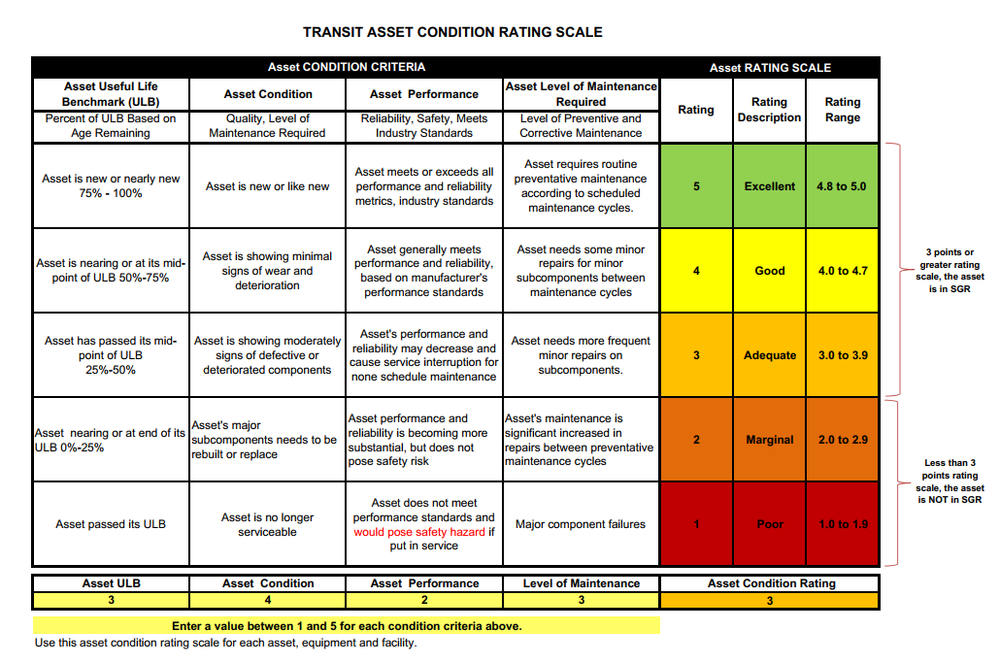
Figure 10 Transit Asset Condition Rating Scale Table

Useful Life Benchmark (ULB)
Rolling stock useful life begins when the vehicle is placed in revenue service and continues until it is removed from revenue service. Useful live benchmark is the measure agencies use to track the performance of revenue vehicles (rolling stock) to set their performance measures targets. Each vehicle type’s ULB estimates how many years that vehicle can be in service and still be in a state of good repair. RCT’s ULB for each revenue vehicle type is listed in the table below. Figure 11 RCT’s ULB Table
Figure 11 RCT’s ULB Table
Vehicle Type | RCT’s ULB (In Years)
Automobile | 8
Bus | 12
Cutaway | 8
Minivan | 8

Planned Capital Expenses
Year | Project | Preservation | Expansion
2026 | Bus Mid-life Overhaul | 1
 | Transit Facilities Truck | 1
 | ADA Supervisor Vehicle |  | 1
 | Fixed Route Cutaways |  | 2
 | Bus Stop Amenities & Pads
2027 | 35’ Coach | 2
 | Bus Mid-life Overhaul | 1
 | Staff Vehicle | 1
 | ADA Cutaways | 2
 | Fixed Route Cutaway | 1
 | Bus Stop Amenities & Pads
2028 | 35’ Coach | 1
 | Bus Stop Amenities & Pads
2029 | ADA Cutaways | 2
 | Staff Vehicle | 1
 | Alternative vehicle power system
2030 | Bus Mid-life Overhaul | 1
 | ADA Cutaway | 1
 | Operator Relief Vehicle | 1
2031 | ADA Cutaways | 7
 | Fixed Route Cutaway | 1
 | 35’ Coach | 1
 | Bus Stop Amenities & Pads
Figure 12 RCT Six Year Capital Programming

Planned Operating Changes
Changes to service hours, facilities, and equipment will be a direct result of available revenue for the next six years. As a public agency, RiverCities Transit cannot increase our main revenue stream without a public vote. Route 511 serving the I-5 corridor has proven to be successful, but a WSDOT Consolidated Grant application will need to be successful to continue beyond June 2027. A separate and linked application may be submitted for Saturday service on this route. Route 433 to Rainier will be discontinued later in 2026 due to poor ridership and the end of City of Rainier funding. Currently, federal funding supporting this service covers at least three years. These funds will be used to pilot extended evening service on selected local routes. The continuation of service to the Lexington-Beacon Hill neighborhoods was confirmed in September 2025. Over the next few years, the primary goal will be to preserve existing service levels and keep expenditures low. RCT will continue to monitor ridership and will plan to meet demand accordingly. We will contact the Port of Longview and Amazon about potential service partnerships. The goal in 2028 is to complete a system-wide service study, including a survey of riders and residents, to determine the best mix of services for the future.
Year | Preservation | Expansion
2026 | Annual service updates;  Apply for grant to maintain I-5 service through 2027-2031 | Evaluate expanded ADA zone;  Pilot later evening service on selected routes
2027 | Annual service updates | Consider expanding I-5 service to Saturday
2028 | Conduct system-wide service study | Evaluate demand for later evening service
2029 | Annual service updates | Consider microtransit pilot project
2030 | Annual service updates | No change
2031 | Annual service updates | No change

Figure 13 RCT’s Operational Changes Table

Multiyear Financial Plan

Capital Improvement:
- Vehicle replacements are expected to be grant funded at up to 80%, matched at 20%, or more if necessary, by local funds.
- Bus stop improvements are shown as 100% local. However, we will use this as a match to leverage additional federal grant funding, if available.
- Other improvements and preservation will be funded by reserves and appropriated through the capital budget presented annually.

Multiyear Capital Purchases
Capital Expenditure | 2026 | 2027 | 2028 | 2029 | 2030 | 2031
Cutaways | 572,000 | 602,145 |  | 370,000 | 250,000 | 1,950,000
Coaches |  | 1,474,000 | 737,000 |  | 750,000 | 765,000
ADA Minivans
Alternate vehicle power system |  |  |  | 1,500,000
Bus stop improvements | 50,000 | 50,000 | 50,000 |  |  | 50,000
Supervisor vehicles | 38,000
Other vehicles | 87,045 | 40,000 |  | 50,000 | 44,000
Bus overhauls | 356,250 | 473,675
Total Capital Expenditures | 1,103,295 | 2,639,870 | 787,000 | 1,920,000 | 1,044,000 | 2,765,000
Capital Revenue | 2026 | 2027 | 2028 | 2029 | 2030 | 2031
Federal Grants | 385,036 | 1,368,067 | 589,600 | 1,554,500 | 847,700 | 1,440,750
State Grants | 457,600 | 713,056 | 0 | 0 | 0 | 828,750
Local Funds | 260,659 | 558,747 | 197,400 | 365,500 | 196,300 | 495,500
Total Capital Revenue | 1,103,295 | 2,639,870 | 787,000 | 1,920,000 | 1,044,000 | 2,765,000
Figure 14 Multiyear Capital Purchases Table

Operating Financial Assumptions:
- Local Sales Tax – A 1.5% growth rate has been used to project out from 2027 through 2031.
- Operating Grants – RCT is allocated Federal Transit Administration 5307 formula funds that can be used for operations or capital. Staff will apply for federal competitive capital funds for vehicle replacements as well. The WSDOT formula and competitive Paratransit grants and the Transit Support grant are dependent upon Climate Commitment Act funding.
- Fares – Assumes growth commensurate with ridership growth – an average of 4.47% per year.
- Salaries and Benefits – The Transit Operator contract with the Amalgamated Transit Union provides for a 3.5% wage increase in 2026 and 2027, as well as longevity pay increases. A 3.5% increase in wages and benefits is assumed per year in years 2028-2031.
- Fuel and Maintenance – Assumed 4% growth.
- Liability Insurance – The insurance market has seen continuing premium increases due to the rise of property values, social costs, and other factors.
- The ADA Paratransit (LIFT) contractor assumed its liability and vehicle property insurance coverage and expenses effective November 2025.
- Other Goods and Services – Assumed 3% growth.
- If operating expenses continue to increase faster than revenue, use of reserves for the required operating match, as well as capital match for replacement vehicles, will limit potential schedule or geographic service growth.

Multiyear Operating Financial Plan
Operating Revenue | 2026 Projected | 2027 Projected | 2028 Projected | 2029 Projected | 2030 Projected | 2031 Projected
Federal Operating Grants | 1,272,547 | 1,551,695 | 1,264,775 | 1,402,690 | 1,438,560 | 1,468,420
WSDOT Competitive Grant | 246,200 | 258,510 | 261,095 | 274,150 | 279,630 | 285,225
WSDOT Formula Grants | 837,692 | 850,000 | 897,750 | 910,540 | 942,410 | 979,395
CTA Revenue (Sales Tax, LCC, Interest) | 5,793,914 | 5,793,900 | 5,880,809 | 5,969,020 | 6,058,555 | 6,149,435
Farebox | 171,439 | 175,570 | 181,490 | 188,885 | 198,250 | 209,780
WSTIP Grants | 2,500 | 9,500 | 9,500 | 9,500 | 9,500 | 9,500
Building Lease | 12,126 | 12,245 | 12,675 | 13,115 | 13,575 | 14,050
State Pool | 5,700 | 6,000 | 6,000 | 6,000 | 6,000 | 6,000
Other Recoveries | 1,500 | 1,550 | 1,550 | 1,550 | 1,550 | 1,550
Total Operating Revenue | 8,343,618 | 8,658,970 | 8,515,622 | 8,775,450 | 8,948,030 | 9,123,355
Annual % Change | - | 3.8% | -1.7% | 3.1% | 2.0% | 2.0%
Operating and Maintenance Expenses | 2026 Projected | 2027 Projected | 2028 Projected | 2029 Projected | 2030 Projected | 2031 Projected
Fixed Route
Salaries & Wages | 2,504,695 | 2,592,360 | 2,683,090 | 2,777,000 | 2,874,195 | 2,974,790
Personnel Benefits | 1,274,933 | 1,319,555 | 1,365,740 | 1,413,540 | 1,463,015 | 1,514,220
Supplies | 35,706 | 36,000 | 37,080 | 38,190 | 39,340 | 40,520
Liability Insurance | 230,861 | 242,405 | 254,525 | 267,250 | 280,615 | 294,645
Other services & charges | 902,939 | 930,025 | 957,930 | 986,665 | 1,016,265 | 1,046,755
Fuel and Vehicle Maintenance | 858,119 | 892,445 | 928,140 | 965,265 | 1,003,870 | 1,044,035
ADA Paratransit
Contract for services | 1,568,810 | 1,631,560 | 1,688,665 | 1,747,770 | 1,808,940 | 1,872,255
Fuel and Maintenance - ADA | 165,972 | 172,610 | 179,515 | 186,695 | 194,165 | 201,930
Liability Insurance | 0 | 0 | 0 | 0 | 0 | 0
Other services & charges | 112,615 | 115,995 | 119,475 | 123,055 | 126,750 | 130,550
Total Operating Expenses | 7,654,650 | 7,932,955 | 8,214,160 | 8,505,430 | 8,807,155 | 9,119,700
Figure 15 RCT’s Multiyear Operating Financial Plan

Projects of Regional Significance
Year | Project Name | Total Project Cost
2026 | South Kelso (Hazel St) Railroad Crossing (ongoing) | $32,230,000
2026 | Port of Longview Rail Corridor Expansion | $24,800,000
2027 | 14th Ave Construction | $3,770,000
2027 | Columbia Heights Road Reconstruction | $16,622,000
2028 | Washington Way/Nichols/26th Roundabout | $7,670,000
2028 | Beech Street Corridor Safety | $49,724,000
2030 | Ocean Beach Highway Corridor | $3,960,000
2031 | 7th Ave & Douglas St Roundabout | $2,160,000
Figure 16 Projects of Regional Significance

2025 Accomplishments

Community Outreach and Partnership Accomplishments
The Mobility Supervisor participates with the City of Longview Accessibility Advisory board. She or the Transit Manager also represent RCT in other groups.
- Updated and distributed New Rider’s Guide to all Paratransit customers.
- Conducted individual travel training for riders with mobility devices to practice boarding without the stress of time constraints.
- Continued participating in regional information forums to exchange information with local and regional elected officials, public works directors, and senate staff.
- Continued participating in the Metropolitan Planning Organization (MPO) Technical Advisory Committee meetings.
- Continued participating in the Southwest Washington Regional Transportation Planning Organization (SWRTPO)
- Maintained a Facebook page and RCTransit.org blog posts to communicate with our riders and the community.
- Participated in local Community Resource Meetings and community events.
- Held travel training events with local high school staff and students in partnership with the Cowlitz-Wahkiakum Council of Governments’ Mobility Management Coordinator.
- Conducted travel training events with the Youth Workforce Program for STEPS and the Longview Transition Academy for vulnerable adults learning life skills.

System Accomplishments

Ridership
The overall system continues to show a slow recovery from the COVID-19 pandemic. Fixed ridership in 2025 grew by 8.9% over 2024. ADA Paratransit ridership in 2025 grew by 11.3% over the prior year.

Operating and Performance Data 2025-2030

Fixed Route | 2025 | 2026 | 2027 | 2028 | 2029 | 2030
 | Actual | Projected | Projected | Projected | Projected | Projected
Revenue Vehicle Hours | 29,894 | 32,245 | 32,245 | 32,245 | 32,245 | 32,245
Total Vehicle Hours | 31,283 | 33,210 | 33,210 | 33,210 | 33,210 | 33,210
Revenue Vehicle Miles | 410,694 | 464,739 | 464,739 | 464,739 | 464,739 | 464,739
Total Vehicle Miles | 427,377 | 479,706 | 479,706 | 479,706 | 479,706 | 479,706
Passenger Trips | 298,138 | 300,000 | 303,000 | 309,060 | 318,330 | 331,065
Diesel Fuel Consumed (Gal) | 69,682 | 68,700 | 72,000 | 72,000 | 72,000 | 72,000
Unleaded Fuel Consumed (Gal) | 9,521 | 12,800 | 12,800 | 12,800 | 12,800 | 11,800
Propane Fuel Consumed (Gal) | 4,006 | 7,900 | 7,700 | 7,700 | 7,700 | 8,700
Figure 17 RCT’s Fixed Route 2025 – 2030 Performance Data

Paratransit | 2025 | 2026 | 2027 | 2028 | 2029 | 2030
 | Actual | Projected | Projected | Projected | Projected | Projected
Revenue Vehicle Hours | 15,762 | 17,020 | 18,380 | 19,850 | 21,440 | 23,155
Total Vehicle Hours | 17,417 | 18,825 | 20,330 | 21,955 | 23,715 | 25,610
Revenue Vehicle Miles | 133,148 | 146,140 | 160,025 | 175,225 | 191,870 | 210,100
Total Vehicle Miles | 147,968 | 161,920 | 177,300 | 194,140 | 212,590 | 232,750
Passenger Trips | 36,301 | 40,265 | 44,655 | 49,520 | 54,220 | 59,370
Gasoline Fuel Consumed (Gal) | 19,848 | 20,400 | 20,400 | 19,000 | 19,000 | 19,000
Propane Fuel Consumed (Gal) | 8,434 | 7,600 | 7,600 | 8,000 | 8,000 | 8,000
Figure 18 RCT’s Paratransit 2025 – 2030 Performance Data

Figure 19 RCT’s Fixed Route and Paratransit Ridership Comparison

Appendix A – Notice of Public Hearing
Notice of Public Hearing published in the Longview Daily News.
NOTICE OF PUBLIC HEARING
COWLITZ TRANSIT AUTHORITY

NOTICE IS HEREBY GIVEN, in accordance with RCW Chapter 42.30, that the Cowlitz Transit Authority will hold a Public Hearing on Wednesday, July 08, 2026, at 4:00 p.m. in the Longview City Hall Council Chambers, 1525 Broadway St., Longview, Washington and by virtual Zoom Webinar.
The purpose of the hearing is to receive any comments concerning the adoption of the Transit Development Plan 2026-2031 and 2025 Annual Report for RiverCities Transit.
The City Hall is accessible for persons with disabilities. Please let us know forty-eight (48) hours in advance if you will need any special accommodations to attend the meeting.
Any person interested may attend and be heard on said matter via a moderator. For information about Zoom accessibility, please contact the Clerk of the Board’s Office at (360) 442-5664

Zoom meeting link: https://us02web.zoom.us/j/89844443333

Dial any of the following numbers:
1 253 215 8782
1 346 248 7799
1 408 638 0968
1 669 900 6833
1 301 715 8592
1 312 626 6799
1 646 876 9923
Webinar ID: 898 4444 3333
No Registration Required

Published: June 25, 2026 and July 2, 2026, in the Longview Daily News

Appendix B - Capital Projects and Estimated Expenditures
Capital Expenditure | 2026 | 2027 | 2028 | 2029 | 2030 | 2031
Cutaways | 572,000 | 602,145 |  | 370,000 | 250,000 | 1,950,000
 | 2 fixed route cutaways 30’; 2 ADA minivans | 2 LIFT and 1 fixed route,  all 24’ |  | 2 LIFT cutaways 24’ | 1 alt powered LIFT cutaway | 1 fixed route & 7 LIFT cutaways, mixed power
Coaches |  | 1,474,000 | 737,000 |  | 750,000 | 765,000
 |  | 2 Biodiesel 35’ | 1 Biodiesel 35’ |  | 1 Biodiesel 35’ | 1 Biodiesel 35’
Infrastructure improvements |  |  |  | 1,500,000
 |  |  |  | Alternate vehicle power system
Bus stop improvements | 50,000 | 50,000 | 50,000 |  |  | 50,000
 | Solar lighting | Shelters, amenities, and pads | Amenities and pads |  |  | Shelters, amenities, and pads
Supervisor vehicles | 38,000 |  |  | 50,000
 | ADA Supervisor vehicle |  |  | Fixed Route Supervisor vehicle
Staff vehicles | 87,045 | 40,000 |  |  | 44,000
 | Transit facilities truck | Staff car |  |  | Driver relief car
Bus overhauls | 356,250 | 473,675
 | 1 Bus to extend useful life | 1-2 Buses to extend useful life
Total Capital Expenditures | 1,103,295 | 2,639,870 | 787,000 | 1,920,000 | 1,044,000 | 2,765,000
All vehicle purchases are replacements for vehicles that have reached the end of their useful life, with the exception of the LIFT supervisor vehicle and the two larger cutaways for our commuter bus service.

